Rolesville Elementary School

1st Grade

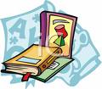  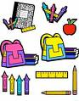

**Supply List**

* **Backpack**  (put name on)
* **Erasers** (cap or rectangular pink; no toys)
* **Pencil box or pouch**
* **#2 pencils** (1 box, preferably plain yellow. No names, to share with class.)
* **Crayons** (No more than 24)
* **Glue Sticks**
* **Dry Erase Markers (blue, red, green & black)**
* **Computer paper**
* **Ziploc Bags** (Boys-Sandwich size/Girls-Gallon size)
* **Set of earbuds (each student will need one)**
* **Book boxes/ magazine holders**
* 2 or 3 composition notebooks (the ones with the black and white marbled cover) with story paper inside - blank space at the top of page/lines on bottom

**Optional** (not required but very, very helpful)

**Tissues**

**Baby wipes**

**Clorox Wipes**

**Please remember that teachers may request a few additional items once school has started.**