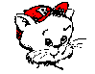
Cougar Cub Supply List
Kindergarten

Each child will need:
- large backpack (no wheels please)  - large towel for rest time  --TOWELS ONLY PLEASE (limited storage)  --label with child's name  - full change of clothes (include socks & underclothes)  --label with child's name  --should be changed each season  - lunch money (can be prepaid--see cafeteria) or home lunch with drink  - sneakers for P. E.  - white plastic 1" notebook binder with clear sheet on front of notebook for page insert  - 1-2 composition books (see example, your color choice)  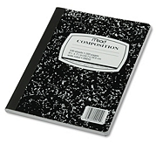  - need 8-10 plastic sheet protectors for T.E.A.M. notebook (or more to use for class extras)  - 1 pack dry erase markers (large)  - 1 box colored pencils (Crayola are good)  - 1 pack yellow highlighters  - 1 pack glue sticks  - 3 x 5 index cards, white | - BOOK BOX--file/magazine holder  --at Walmart, Target, Office max, etc. (see example, your color choice)  --think sturdy as students will use these multiple school years  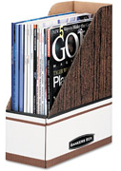 or 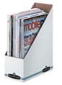 or  NOT ( books will fall out)  - small stickers--need LOTS during the year  - large erasers for paper--sometimes are pink rectangles  - 1 box tissues, like Kleenex  - 1 pack copy paper--white
WISH LIST FOR CLASS (will need now & during the year):
- hand sanitizer (pump bottle)
- wet wipes (package or box)
- napkins
- freezer ziploc type bags (gallon & quart)
- TREASURE BOX PRIZES --like birthday prizes, will need many during the year
- Playdoh--any color

